|  |  |  |
| --- | --- | --- |
| |  |  | | --- | --- | |  |  | |
| **<Hospital>** |
| **Functional Specification Design Document** |
|  |

|  |  |  |
| --- | --- | --- |
| Author | : | * Muhammad Randy Maulana * Rena Dian Puspita * Nuzul Fithra Ryaldi |
| Version | : | 1.0 |
| Last Update | : | 24.8.2022 |
| Total Page Count | : | 29 |

**Copyright © 2022 Bootcamp JDT 10. All rights reserved. These materials are confidential and proprietary to Jatis Solutions and no part in these materials should be reproduced, published in any form by any means, electronic or mechanical including photocopy or any information storage or retrieval system nor should the materials be disclosed to third parties without the express written authorization of Jatis Solutions.**

**Version History**

| **Version** | **Date** | **By** | **Change Summary** |
| --- | --- | --- | --- |
| -- | -- | -- | * Initial Draft |
|  |  |  |  |
|  |  |  |  |
|  |  |  |  |
|  |  |  |  |
|  |  |  |  |

**Table of Contents**

1. Introduction 6

1.1. Purpose 6

1.2. Convention 6

1.2.1. Field Type 6

1.2.2. Data Type 6

1.2.3. Field Status 7

1.2.4. Controls Type 7

2. Functional Design 8

2.1. System Overview 8

2.2. Halaman Login 8

2.2.1. Use Case 8

2.2.2. Activity Diagram 9

2.2.3. User Interface 9

2.2.4. Field Description 9

2.2.5. Action Control 10

2.3. Halaman LandingPage Admin 10

2.3.1. Use Case 10

2.3.2. Activity Diagram 11

2.3.3. User Interface 12

2.3.4. Field Description 12

2.3.5. Action Control 12

2.4. Halaman Register Admin 13

2.4.1. Use Case 13

2.4.2. Activity Diagram 14

2.4.3. User Interface 14

2.4.4. Field Description 15

2.4.5. Action Control 15

2.5. Halaman Register Doctor 16

2.5.1. Use Case 16

2.5.2. Activity Diagram 17

2.5.3. User Interface 17

2.5.4. Field Description 18

2.5.5. Action Control 18

2.6. Halaman Register Patient 19

2.6.1. Use Case 19

2.6.2. Activity Diagram 20

2.6.3. User Interface 20

2.6.4. Field Description 21

2.6.5. Action Control 21

2.7. Halaman View Patients By Id Doctor 22

2.7.1. Use Case 22

2.7.2. Activity Diagram 22

2.7.3. User Interface 23

2.7.4. Field Description 23

2.7.5. Action Control 23

2.8. Halaman Patient Detail 24

2.8.1. Use Case 24

2.8.2. Activity Diagram 24

2.8.3. User Interface 25

2.8.4. Field Description 25

2.8.5. Action Control 26

2.9. Halaman Giving Treatment 27

2.9.1. Use Case 27

2.9.2. Activity Diagram 27

2.9.3. User Interface 28

2.9.4. Field Description 28

2.9.5. Action Control 28

**Table of Figures**

**No table of figures entries found.**

**Table of Tables**

*Table 1 - Table Field Type 6*

*Table 2 - Table Data Type 6*

*Table 3 -Table Field Status 6*

*Table 4 -Table Controls Type 6*

*Table 5 – Field Description Halaman Login 8*

*Table 6 – Action Control Halaman Login 8*

*Table 7 – Field Description Halaman Landing Page Admin 11*

*Table 8 – Action Control Halaman Landing Page Admin 11*

*Table 9 – Field Description Halaman Register Admin 14*

*Table 10 – Action Control Halaman Register Admin 14*

*Table 11 – Field Description Halaman Register Doctor 17*

*Table 12 – Action Control Halaman Register Doctor 17*

*Table 13 – Field Description Halaman Register Patient 20*

*Table 14 – Action Control Halaman Register Patient 20*

*Table 15 – Field Description Halaman View Patient By Id Doctor 22*

*Table 16 – Action Control Halaman View Patient By Id Doctor 22*

*Table 17 – Field Description Halaman Patient Detail 24*

*Table 18 – Action Control Halaman Patient Detail 25*

*Table 19 – Field Description Halaman Giving Treatment 27*

*Table 20 – Action Control Halaman Giving Treatment 28*

# Introduction

## Purpose

Dokumen ini bersifat sebagai dokumen addendum dari VO yang telah disepakati, yang tercantum dalam dokumen ini hanyalah perubahan-perubahan yang terjadi terhadap aplikasi. Dokumen ini dibuat berdasarkan dokumen VO.

## Convention

Berikut beberapa istilah yang digunakan dalam dokumen ini

### Field Type

|  |  |
| --- | --- |
| **Abbreviation** | **Description** |
| TSL | Textbox Single Line |
| TML | Textbox Multiple Line |
| DDL | Dropdown List |
| CKB | Check Box |
| RDB | Radio Button |
| LBL | Label |
| DPL | Date Pick List  calendar |
| SCH | Search  search |

**Table 1 - Table Field Type**

### Data Type

|  |  |
| --- | --- |
| **Abbreviation** | **Description** |
| NUM (<length>,<decimal length>) | Numeric |
| APB (<length>) | Alphabet |
| APN (<length>) | Alphanumeric |
| DTE | Date |
| DTM | Date and Time |

**Table 2 - Table Data Type**

### Field Status

|  |  |
| --- | --- |
| **Abbreviation** | **Description** |
| M | Mandatory |
| O | Optional |
| D | Display |
| C | Sistem calculated |

**Table 3 -Table Field Status**

### Controls Type

|  |  |
| --- | --- |
| **Abbreviation** | **Description** |
| BTN | Button  button |
| HYP | Hyperlink  View | Edit |
| TAB | Tab |

**Table 4 -Table Controls Type**

# Functional Design

## System Overview

System di bentuk untuk memudahkan rumah sakit untuk menginput dan memberikan treatments pada pasien, sehingga rumah sakit berjalan dengan lebih efisien serta memiliki data dalam bentuk digital

## Halaman Login

Dihalaman ini berfungsi untuk menginput username dan password,yang dimiliki user untuk bias mengakses halaman lain.

### Use Case



### Activity Diagram

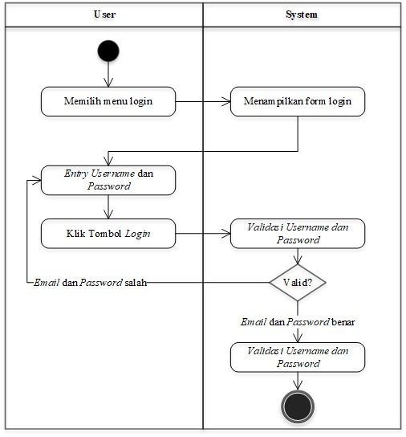

### User Interface

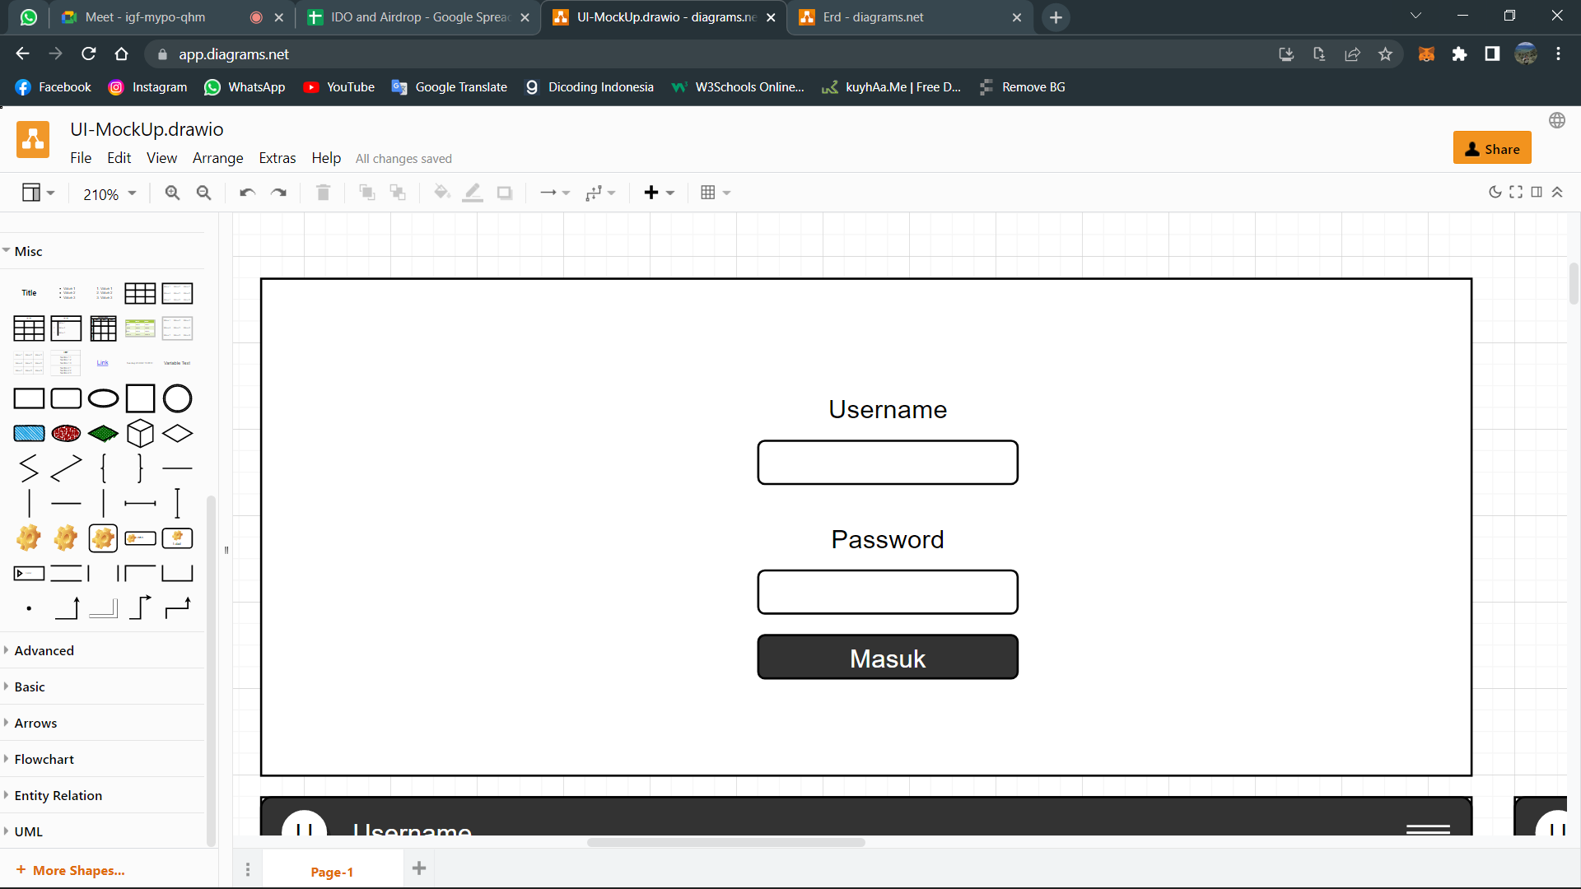

### Field Description

|  |  |  |  |  |
| --- | --- | --- | --- | --- |
| No | Nama Field | Type | Size | Keterangan |
| 1 | User Name | APN | 255 | Untuk kebutuhan login dari setiap users Hospital |
| 2 | Password | APN | 255 | Untuk kebutuhan login dari setiap users Hospital |

**Table 5 – Field Description Halaman Login**

### Action Control

|  |  |  |
| --- | --- | --- |
| **Abbreviation** | **Description** | **Action** |
| BTN | Button | if (role == "USER_TYPE_ADMIN") {                  navigate("/SuperAdmin");              } else {                  navigate("/Doctors");              } |

**Table 6 – Action Control Halaman Login**

## Halaman LandingPage Admin

### Use Case



### Activity Diagram



### User Interface

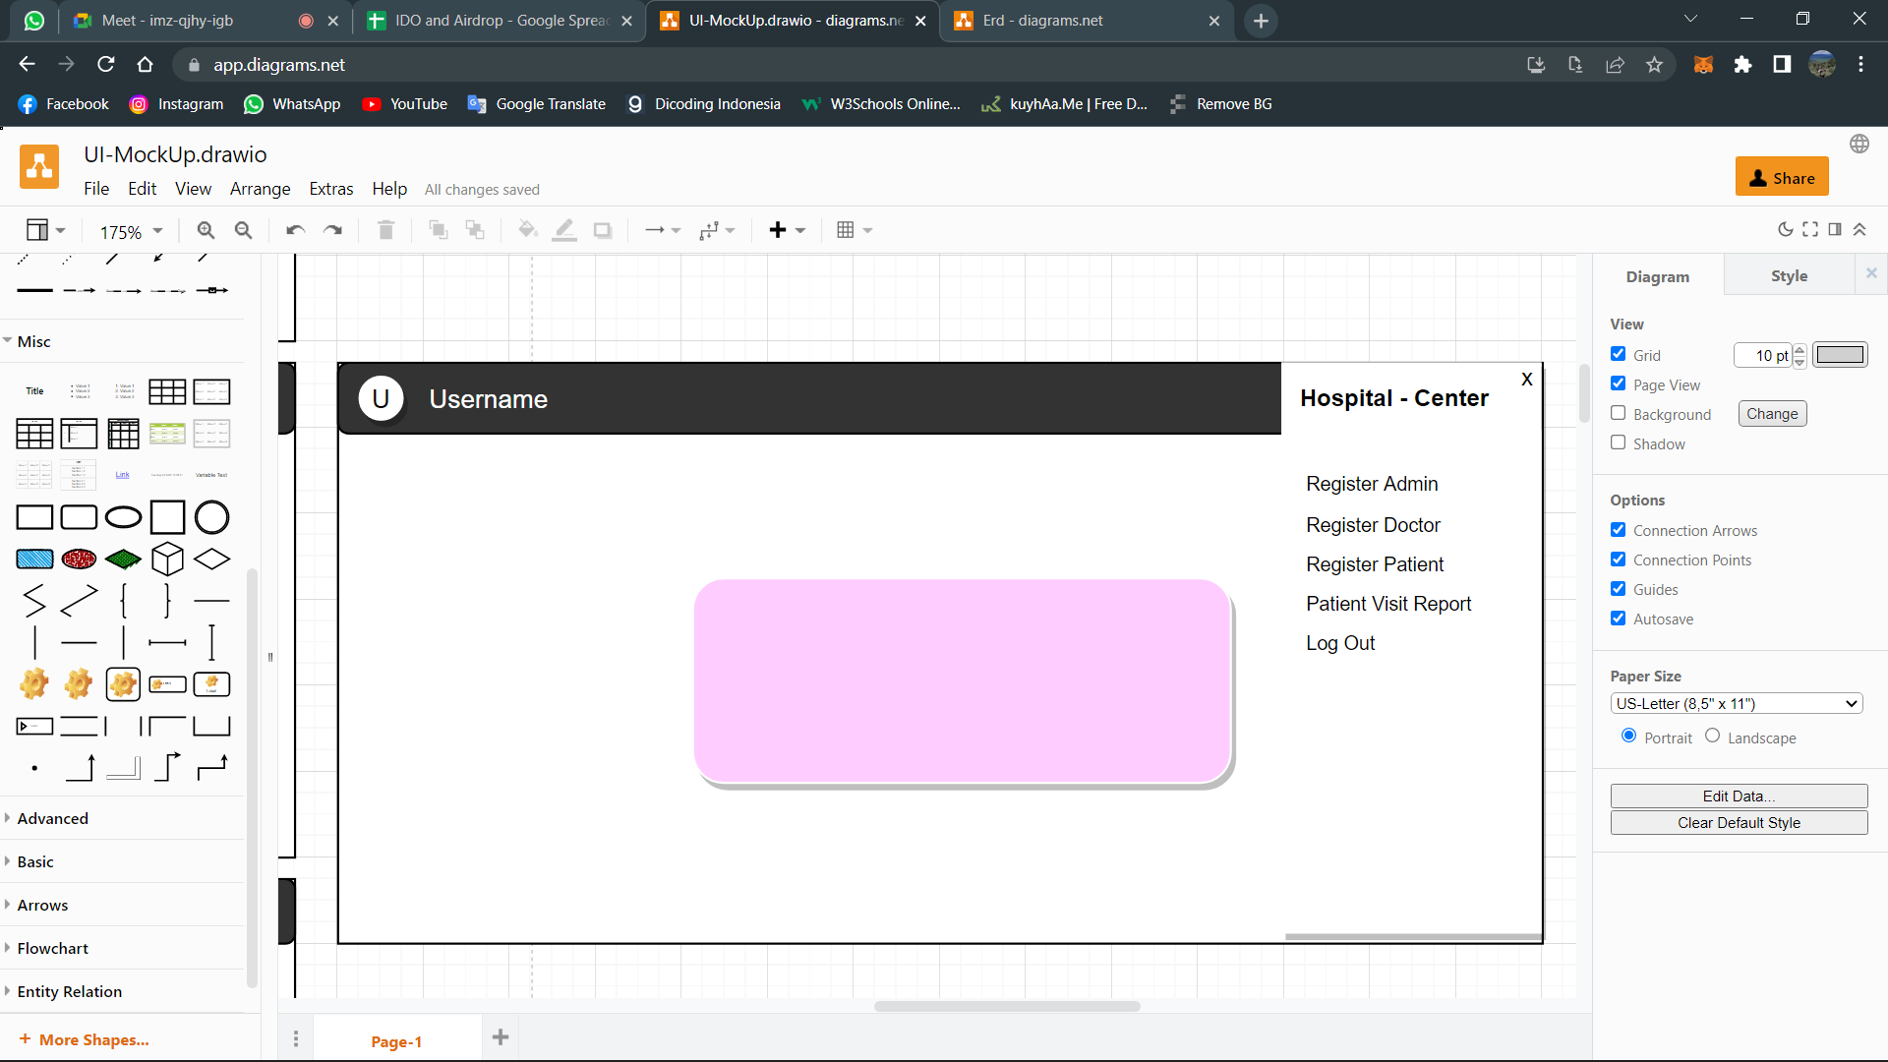

### Field Description

|  |  |  |  |  |
| --- | --- | --- | --- | --- |
| No | Nama Field | Type | Size | Keterangan |
| 1 |  |  |  |  |

**Table 7 – Field Description Halaman Landing Page Admin**

### Action Control

|  |  |  |
| --- | --- | --- |
| **Abbreviation** | **Description** | **Action** |
| BTN | Button | /EditUser |
| BTN | Button | Side bar -> Register admin, doctor, patient, patient visit report. logout |

**Table 8 – Action Control Halaman Landing Page Admin**

## Halaman Register Admin

### Use Case



### Activity Diagram



### User Interface

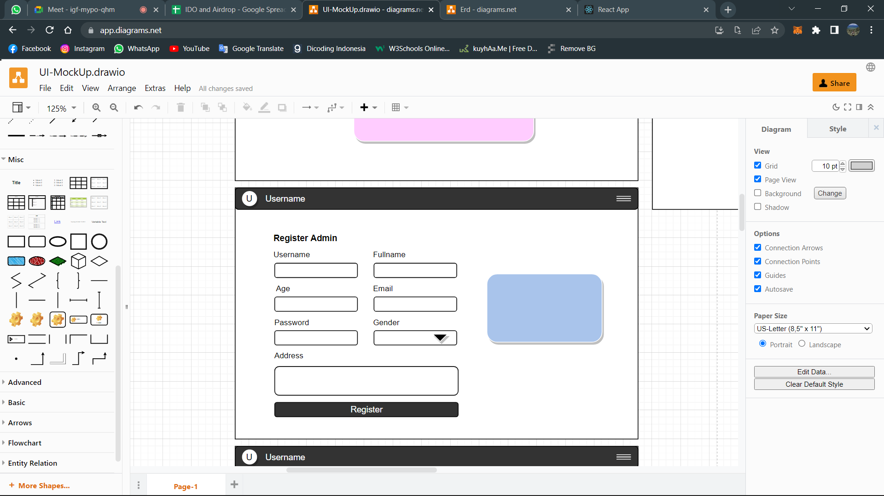

### Field Description

|  |  |  |  |  |
| --- | --- | --- | --- | --- |
| No | Nama Field | Type | Size | Keterangan |
| 1 | User Name | APN | 255 |  |
| 2 | Full Name | APN | 255 |  |
| 3 | Age | NUM | 20 |  |
| 4 | Email | APN | 255 |  |
| 5 | Password | APN | 255 |  |
| 6 | Gender | APB | 255 |  |
| 7 | Address | APN | 255 |  |

**Table 9 – Field Description Halaman Register Admin**

### Action Control

|  |  |  |
| --- | --- | --- |
| **Abbreviation** | **Description** | **Action** |
| BTN | Button |  |

**Table 10 – Action Control Halaman Register Admin**

## Halaman Register Doctor

### Use Case



### Activity Diagram



### User Interface

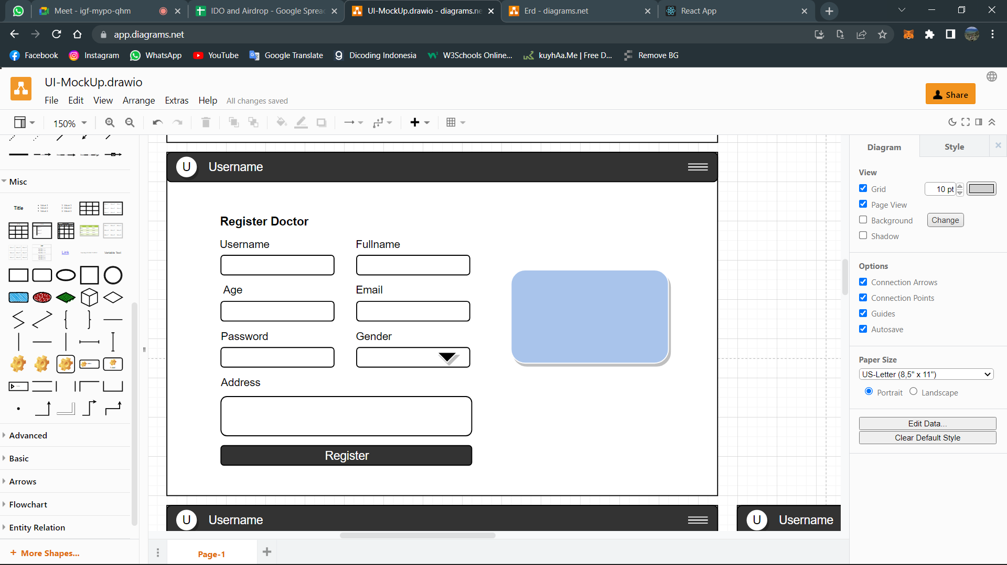

### Field Description

|  |  |  |  |  |
| --- | --- | --- | --- | --- |
| No | Nama Field | Type | Size | Keterangan |
| 1 | User Name | APN | 255 |  |
| 2 | Full Name | APN | 255 |  |
| 3 | Age | NUM | 20 |  |
| 4 | Email | APN | 255 |  |
| 5 | Password | APN | 255 |  |
| 6 | Gender | APB |  |  |
| 7 | Address | APN | 255 |  |

**Table 11 – Field Description Halaman Register Doctor**

### Action Control

|  |  |  |
| --- | --- | --- |
| **Abbreviation** | **Description** | **Action** |
| BTN | Button |  |

**Table 12 – Action Control Halaman Register Doctor**

## Halaman Register Patient

### Use Case



### Activity Diagram



### User Interface

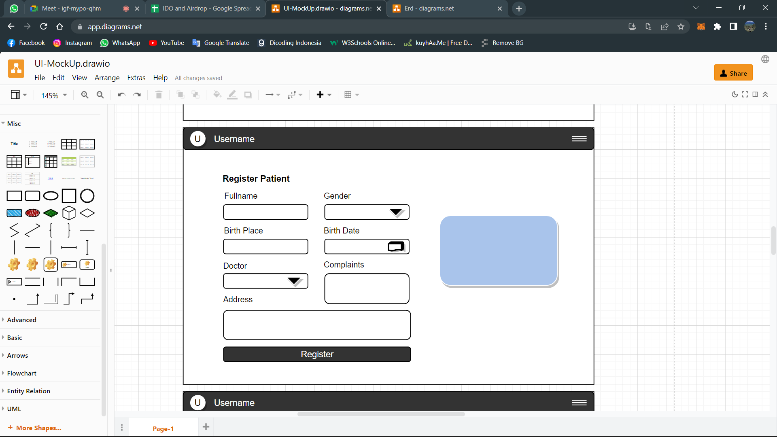

### Field Description

|  |  |  |  |  |
| --- | --- | --- | --- | --- |
| No | Nama Field | Type | Size | Keterangan |
| 1 | Full Name | APN | 255 |  |
| 2 | Gender | APN | 255 |  |
| 3 | Birth Date | DATe | 20 |  |
| 4 | Birth Place | APN | 255 |  |
| 5 | Doctor | APN | 255 |  |
| 6 | Complaints | APB | 255 |  |
| 7 | Address | APN | 255 |  |

**Table 13 – Field Description Halaman Register Patient**

### Action Control

|  |  |  |
| --- | --- | --- |
| **Abbreviation** | **Description** | **Action** |
| BTN | Button |  |

**Table 14 – Action Control Halaman Register Patient**

## Halaman View Patients By Id Doctor

### Use Case



### Activity Diagram



### User Interface

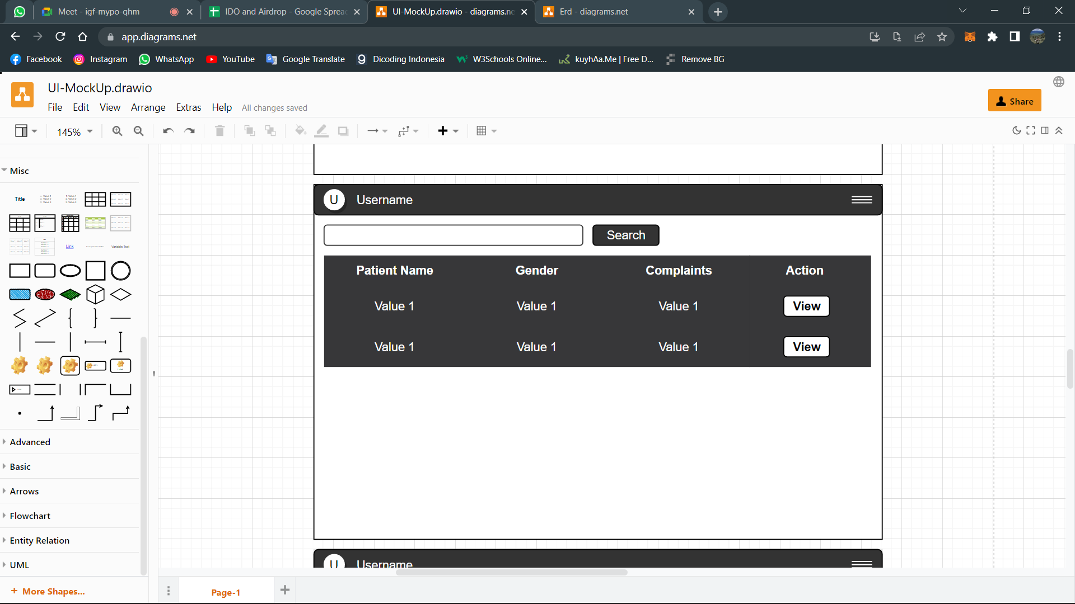

### Field Description

|  |  |  |  |  |
| --- | --- | --- | --- | --- |
| No | Nama Field | Type | Size | Keterangan |
| 1 | Patient Name | APN | 255 |  |
| 2 | Gender | APN | 255 |  |
| 3 | Complaints | APN | 255 |  |
| 4 | Action | BTN |  |  |

**Table 15 – Field Description Halaman View Patient By Id Doctor**

### Action Control

|  |  |  |
| --- | --- | --- |
| **Abbreviation** | **Description** | **Action** |
| BTN | Button |  |
| BTN | Button |  |

**Table 16 – Action Control Halaman View Patient By Id Doctor**

## Halaman Patient Detail

### Use Case



### Activity Diagram



### User Interface

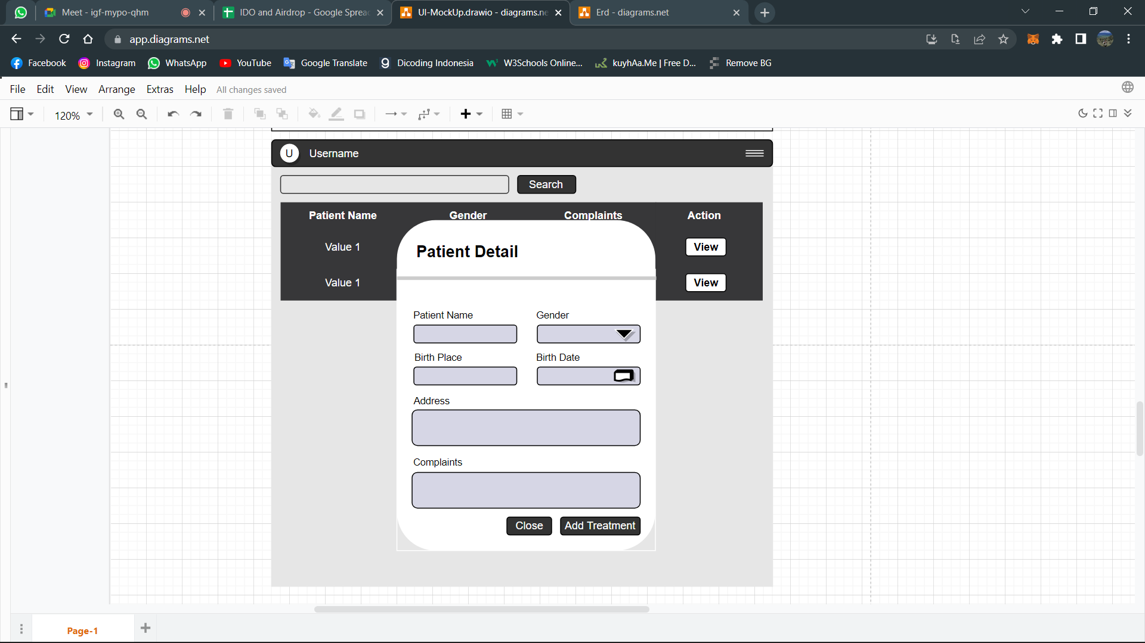

### Field Description

|  |  |  |  |  |
| --- | --- | --- | --- | --- |
| No | Nama Field | Type | Size | Keterangan |
| 1 | Patient Name | APN | 255 |  |
| 2 | Gender | APN | 255 |  |
| 3 | Birth Place | APN | 255 |  |
| 4 | Birth Date | BTN |  |  |
| 5 | Address | APN | 255 |  |
| 6 | Complaints | APN | 255 |  |

**Table 17 – Field Description Halaman Patient Detail**

### Action Control

|  |  |  |
| --- | --- | --- |
| **Abbreviation** | **Description** | **Action** |
| BTN | Button |  |
| BTN | Button |  |

**Table 18 – Action Control Halaman Patient Detail**

## Halaman Giving Treatment

### Use Case



### Activity Diagram



### User Interface

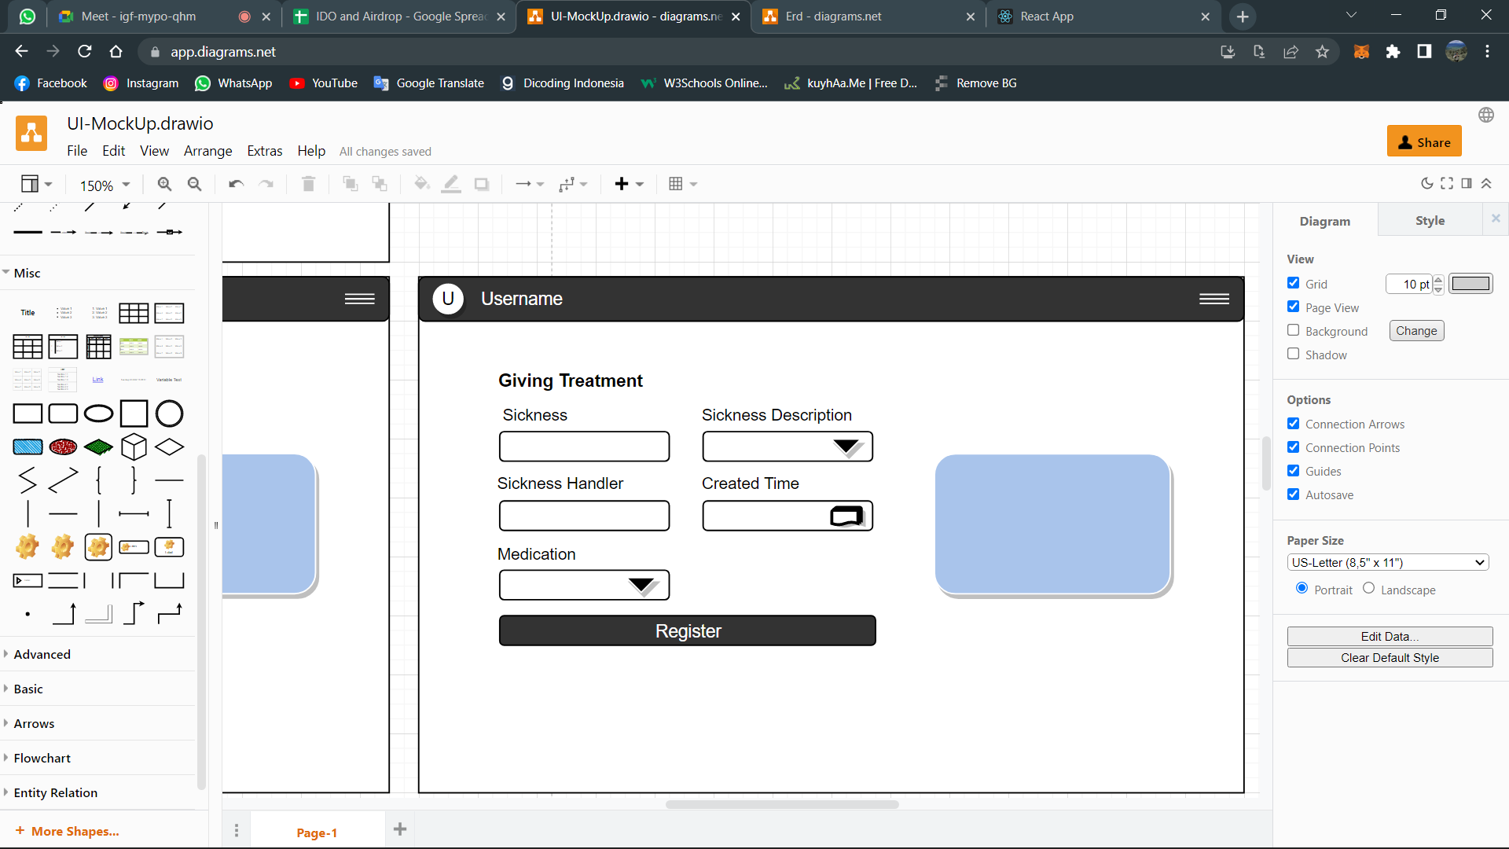

### Field Description

|  |  |  |  |  |
| --- | --- | --- | --- | --- |
| No | Nama Field | Type | Size | Keterangan |
| 1 | Sickness | APN | 255 |  |
| 2 | Sickness Description | APN | 255 |  |
| 3 | Sickness Handler | APN | 255 |  |
| 4 | Created Time | APN | 255 |  |
| 5 | Medication | APN | 255 |  |

**Table 19 – Field Description Halaman Giving Treatment**

### Action Control

|  |  |  |
| --- | --- | --- |
| **Abbreviation** | **Description** | **Action** |
| BTN | Button |  |

**Table 20 – Action Control Halaman Giving Treatment**

## ERD

